Sale-based Property Valuation Model Development and Analysis

Project 2 | BUSI 444

Hamed Helisaz

4305475

March 24, 2025

Table of Contents
Introduction 4
Step 1 – Choose a Valuation Model 4
Step 2 – Variable Review 5
General Qualitative (GQ variables) 5
Building Quality (BQ variables) 5
Building Additive (BA variables) 5
Land Qualitative (LQ variables) 6
Land Additive (LA variables) 6
Other Building Qualitative and Additive (OQ and OA variables) 6
Step 3, 4, and 5 – Examine Potential Independent Variables and Transform as Necessary 6
Time Adjustment for Sale Price 6
Variable Examination 8
Step 6 – List Variables for Calibration 13
Groups of Variables 13
TEST/MODEL Split 15
Step 7 – Model Calibration 15
Step 8 – Model Testing 17
Neighborhood Adjustment 17
Evaluating Model Quality Using Holdout Sample 19
Evaluating Model Quality Using Entire Dataset 19
Modeling ASR 20
Final Check for Neighborhood 21
Conclusion 21
Appendix 23
A.1. Data Description 23
Building Quality (BQ variables) 23
Building Additive (BA variables) 23
Land Qualitative (LQ variables) 24
Other Building Qualitative and Additive (OQ and OA variables) 24
A.2. Variable Transformation 25
Variable Examination 26
A.3. Step 7 – Model Calibration 30
Stepwise Regression 30
A.4. Step 8 – Model Testing 31
Model Adjustment 31
Syntax (in R) 34

Introduction
This report details the development and calibration of a regression model for property valuation. The model is designed to estimate property market values based on the analysis of 466 sales data and relevant property characteristics. The sales data utilized in the model development have been adjusted to reflect market values as of July 1st, 2017. The intended users of this valuation model are clients and stakeholders requiring accurate and reliable property value assessments. The scope of this project includes the selection of a suitable valuation model, the classification and transformation of independent variables, and the calibration and validation of the model to ensure accuracy and reliability in its predictive capacity.
This project employs a structured methodology for model development. Initially, a suitable valuation model is selected, and a review of the variables is conducted. Independent variables are then examined to determine their potential applicability to the model. To ensure consistency, sale prices are adjusted to reflect market values as of the valuation date, July 1st, 2017. Following this, the variables are prepared for calibration, and the dataset is divided into training and testing subsets. The model is calibrated using the training dataset and subsequently validated using the testing dataset. The model's final evaluation involves a series of tests to confirm that valuations are fair and unbiased with respect to various property characteristics.

Step 1 – Choose a Valuation Model
The first step in developing the regression model is to define the mathematical structure. The model we will use is designed to estimate the market value (MV) of a property by considering various qualitative and additive factors related to the building, land, and other structures. The general form of the model is as follows:
$$MV=Σ{GQ}_{B} +⟨Σ{BQ}_{B}+Σ({BQ}_{M}×BA)⟩+⟨Σ{LQ}_{B}+Σ({LQ}_{M}×LA)⟩+Σ({OQ}_{M}×OA)$$
Where:
- MV: Market value of the property.
- $Σ{GQ}_{B}$​: Sum of general qualitative factors in binary form
- $Σ{BQ}_{B}$: Sum of building qualitative factors in binary form
- ${BQ}_{M}$: Building qualitative factors in multiplicative form.
- $BA$: Building additive factors.
- $Σ{LQ}_{B}$​: Sum of land qualitative factors in binary form
- ${LQ}_{M}$​: Land qualitative factors in multiplicative form
- LA: Land additive factors
- ${OQ}_{M}$: Other building qualitative factors in multiplicative form
- OA: Other building additive factors
Following the definition of the valuation model, the subsequent step involves a detailed review of the available independent variables to ensure appropriate categorization for inclusion in the model.

Step 2 – Variable Review
To implement the model, we need to categorize the available independent variables into the appropriate groups. The variables from the dataset can be classified into the following categories:

General Qualitative (GQ variables)
General qualitative variables capture broad locational influences that affect the property’s value. These factors include the neighbourhood, proximity to amenities, and other location-specific characteristics. In our dataset, NEIGH falls into this category:

Building Quality (BQ variables)
Building quality variables represent the characteristics and condition of the main building. These factors include construction quality, age, and effective year built, which accounts for renovations and depreciation. The following variables are categorized as building quality factors. Since the columns are repeated from Project 1, the data description is not included in the main text, but they are available in the Appendix.
MBMANCLS | MBYRBLT | MBEFFYR
LINMCLS | MBMCLSDV

Building Additive (BA variables)
Building additive variables include measurable features of the main building, such as floor area, number of rooms, and other physical characteristics. The following variables are categorized as building additive factors:
BEDROOMS | BATHS | FAMILYRM
FIREPLCS | FLRAREA1 | FLRAREA2
BSMTFIN | CRWLAREA | BMSTAREA
UNFINBMT | AREA1_2 | TOTAREA
BASESTE | HEATTYPE | SPLITVL

Land Qualitative (LQ variables)
Land qualitative variables represent features of the land that influence its value, such as lot shape, topography, and location-specific characteristics. These variables are often binary, indicating the presence or absence of a feature. The following variables are categorized as land qualitative factors:
CORNER | WOODED | PIE_SHPE
SLOPE | ABV_ROAD | CULDESAC
CONDUIT | ALLEY | SIDEWALK

Land Additive (LA variables)
Land additive variables represent measurable features of the land, such as LOT_SIZE

Other Building Qualitative and Additive (OQ and OA variables)
Other building qualitative and additive variables represent features of additional structures on the property, such as garages, carports, and outbuildings. These variables can be qualitative (e.g., quality class) or additive (e.g., area). The following variables are categorized as other building factors:
GARAGEFL | CARPTFL | CP_AREA
GAR_AREA | GAR_TYPE
Prior to their use in the model, the variables require examination and, where necessary, transformation to ensure their suitability for regression analysis.

Step 3, 4, and 5 – Examine Potential Independent Variables and Transform as Necessary
A critical transformation applied to the data involves adjusting sale prices to a specific date to account for temporal market variations. I need to redo the time adjustment for the sale price based on feedback from the first project.

Time Adjustment for Sale Price
Although the median of SAR (Sale Price Assessed Value Ratio) does not significantly change month over month (project 1), average value of SAR changes month from month and I should ensure the values are adjusted to reflect the value as of July 1st, 2017. The table below shows the variation in the average of SAR in different months. Note that the mean value for SAR is approximately the SAR in the middle of the month and so the SAR on July 1st is obtained by averaging the mean (SAR) for the month of June and July.
Group | Month | Mean (SAR) | Mean (SAR) on July 1st | Factor
3 | March | 1.018 | 1.031 | 1.013
4 | April | 1.032 | 1.031 | 0.999
5 | May | 1.030 | 1.031 | 1.001
6 | June | 1.022 | 1.031 | 1.009
7 | July | 1.041 | 1.031 | 0.991
8 | August | 1.020 | 1.031 | 1.011
9 | September | 1.056 | 1.031 | 0.977
10 | October | 1.053 | 1.031 | 0.979

Therefore, the time adjusted sale price will be obtained as follows:
$$Time Adjusted Sale Price= Factor ×Sale Price$$
To ensure that the adjusted sale price is equally distributed over months, I run Kruskal-Wallis test for the adjusted sale price and p-value for the test is 0.186 which is well above the threshold of 5%.
Following what recommended by the textbook, I form the size adjustment factor for land size as follows and calculate the adjusted lot size:
$$Size Factor= {\left({Average Lot Size}/{Lot Size}\right)}^{\frac{x}{2}} \\ Adjusted Lot Size=Size Factor ×Lot Size$$
Doing tries and error, I confirmed that the factor 1.2 works with our data using the size factor obtained for Project 1.
Next the manual classes should be included in the related variables. Manual classes for main building, carport and garage are available but the scaled numeric value is only available for main building. Using the information given in Project 1, I calculated the scaled value for all manual classes (Table A.1)
$$Adjusted Floor Area 1=Linear MC ×Floor Area 1 \\ Adjusted Floor Area 2=Linear MC ×Floor Area 2 \\ Adjusted Finished Bastement=Linear MC ×Finished Basement \\ Adjusted Garage Area =Linear {MC}_{Garage}×Garage Area \\ Adjusted Carport Area= Linear {MC}_{Carport} ×Carport Area$$

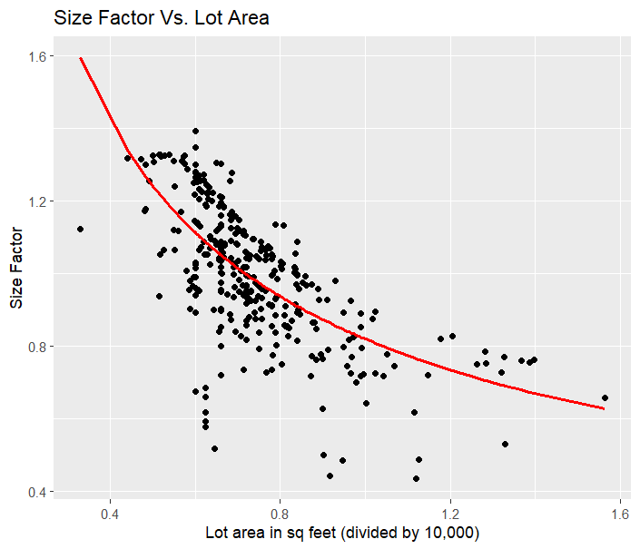
Next the effective year should be calculated by subtracting the effective year built from 2017:
$$Effective Age= 2017-Effect Year Built$$
After the time adjustment, a detailed examination of each variable is needed to analyze its statistical properties, identify potential outliers, and prepare the data for subsequent modeling.

Variable Examination
First, I need to provide a descriptive analysis for each variable to find the range for each and identify outliers if any.
Descriptive Analysis for Continuous Variables
 | Min | Max | Mean | Median
flrarea1_adjusted | 279.9 | 2,247.2 | 1,023.0 | 1,009.3
flrarea2_adjusted | 0.0 | 1,249.3 | 32.0 | 0.0
bsmtfin_adjusted | 0.0 | 1,600.0 | 439.8 | 451.5
crwlarea | 0.0 | 1,331.0 | 57.9 | 0.0
bsmtarea | 0.0 | 1,978.0 | 998.9 | 1,040.0
unfinbmt | 0.0 | 1,826.0 | 544.6 | 531.0
area1_2_adjusted | 279.9 | 3,496.5 | 1,055.0 | 1,020.6
totarea_adjusted | 279.9 | 3,578.0 | 1,493.9 | 1,501.5
lot_size_adjusted | 5,131.1 | 9,635.6 | 6,998.3 | 6,891.6
effage | 2.0 | 74.0 | 25.6 | 23.0
gar_area_adjusted | 0.0 | 748.8 | 82.0 | 0.0
cp_area_adjusted | 0.0 | 663.0 | 132.8 | 0.0
saleprice_time_adjusted | 68,099.9 | 305,608.2 | 148,945.7 | 144,445.0

According to the table above, there do not appear to be any outliers in the variables. The adjusted floor area for the first-floor ranges from 279.9 to 2,247.2 square feet, which is within a reasonable range. The second-floor area can go up to 1,249.3 square feet, and the adjusted basement finished area reaches up to 1,600 square feet, with some records having zero values in these categories. Crawl space and basement area also show a maximum of 1,331 and 1,987 square feet, respectively, while the unfinished basement area can go up to 1,826 square feet. The adjusted area for both floors combined (area1_2_adjusted) ranges from 279.9 to 3,496.5 square feet, which aligns with the overall distribution of floor and basement areas. Total adjusted area (totarea_adjusted) ranges from 279.9 to 3,578.0 square feet, which again appears reasonable, considering the ranges of individual floor and basement areas. The lot size adjusted variable shows a range of 5,131.1 to 9,635.6 square feet, and this is also within a typical range for residential properties. The effective age of the property (effage) ranges from 2 to 74 years, with a mean of 25.6, suggesting a reasonable mix of newer and older properties in the dataset. Finally, the garage area adjusted variable goes up to 748.8 square feet, with some properties having no garage area (0 value), which is expected. The carport area adjusted (cp_area_adjusted) also shows a range from 0 to 663 square feet, with some zero values. The sale price adjusted (saleprice_time_adjusted) ranges from $68,099.9 to $305,608.2, with a mean of 148,945.7, which seems consistent with the property sizes and characteristics observed in the other variables. There do not appear to be any extreme outliers in terms of price, given the variation in property sizes and ages.
Now, I do the same for categorical variable by finding the frequency table.
Frequency Tables
 | 0 | 1 | 2 | 3 | 4
bedrooms | 0 | 0 | 111 | 335 | 20
familyrm | 164 | 278 | 24
fireplcs | 143 | 215 | 108
baseste | 442 | 24
splitlvl | 432 | 34
corner | 394 | 72
wooded | 430 | 36
pie_shape | 439 | 27
slope | 406 | 60
abv_road | 385 | 81
culdesac | 437 | 29
conduit | 166 | 300
alley | 318 | 148
sidewal | 423 | 43
garagefl | 333 | 133
carptfl | 268 | 198

bath | 1 | 1.5 | 1.75 | 2 | 2.25 | 2.5 | 2.75
# | 159 | 113 | 78 | 43 | 41 | 21 | 11

heattype | 0 | 1 | 2 | 3 | 4 | 5 | 6 | 7 | 8
# | 0 | 3 | 403 | 14 | 12 | 7 | 12 | 7 | 8

The frequency tables above show that there are sufficient records for each category of the categorical variable, except for heat type 1, which contains only three records. Given the description of heat types, it makes sense to merge heat types 1 and 2 as they are both gases. Likewise, heat types 5 and 6 share similar characteristics, so I merged these two groups as well. These adjustments help ensure that each category has an adequate number of records for analysis.
Then, I am examining the relationship between the dependent variable (time adjusted sale price) and independent variables after transformation. Note that I do not include the neighborhood in the modeling as the variable is expected to include many features in the property. I will check the performance of final mode in various neighborhood at the end. To start, I check for highly correlated independent variables to prevent multicollinearity.
Correlation between independent variables
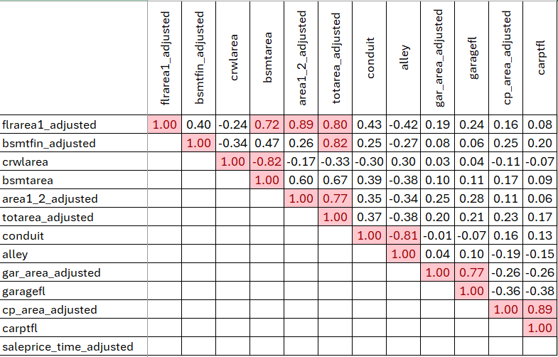
The table shows that the first-floor area is highly correlated with the basement area, total area, and the combined first and second-floor area, which is expected. The finished basement area is also correlated with the total area. Since the total area includes the first and second floors as well as the basement, this overlap makes sense. Crawlspace and basement areas are also correlated. Similarly, alley and conduit show a strong correlation. Additionally, garage area and garage presence, as well as carport area and carport presence are all highly correlated.
To avoid multicollinearity, only one variable from each group of highly correlated variables should be included in the model. The decision on which variable to keep depends on its correlation with the time-adjusted sale price. The variable with the higher correlation should be kept, and the one with a lower correlation should be excluded. The correlation between the time-adjusted sale price and the independent variables is shown in the table below. Variables highlighted in green have a correlation of 0.7 or above, those highlighted in yellow have a correlation between 0.2 and 0.6, and the remaining variables are not highlighted.
Correlation of Independent Variables with Response Variables
totarea_adjusted | 0.738 | familyrm | 0.386 | culdesac | 0.299
area1_2_adjusted | 0.785 | bsmtfin_adjusted | 0.407 | splitlvl | 0.279
flrarea1_adjusted | 0.791 | fireplcs | 0.515 | cp_area_adjusted | 0.187
baths | 0.651 | conduit | 0.566 | baseste | -0.068
bsmtarea | 0.626 | unfinbmt | 0.225 | abv_road | -0.054
effage | -0.658 | pie_shpe | 0.242 | slope | -0.033
alley | -0.499 | gar_area_adjusted | 0.250 | sidewalk | -0.112
crwlarea | -0.304 | flrarea2_adjusted | 0.256 | heattype | 0.104
bedrooms | 0.364 | lot_size_adjusted | 0.368 | carptfl | 0.118

Before selecting variables, it is important to check the plots of the independent variables against the time-adjusted sales. I have included plots for the highly correlated variables (highlighted in green) here. The plots for the other variables are available in the Appendix (Fig A.1 – A.4). For continuous variables, scatter plots with R-squared values are included, while for categorical variables, box plots are used.
Note that in the scatter plots, independent variables with zero value are excluded. For example, the plot for basement area only includes those folios with basement area more than zero. Based on the tables and figures above, I selected the following potential variables for the model. Variables with low correlation to the response variable (<0.1) or low R² were excluded, as they don’t appear relevant.

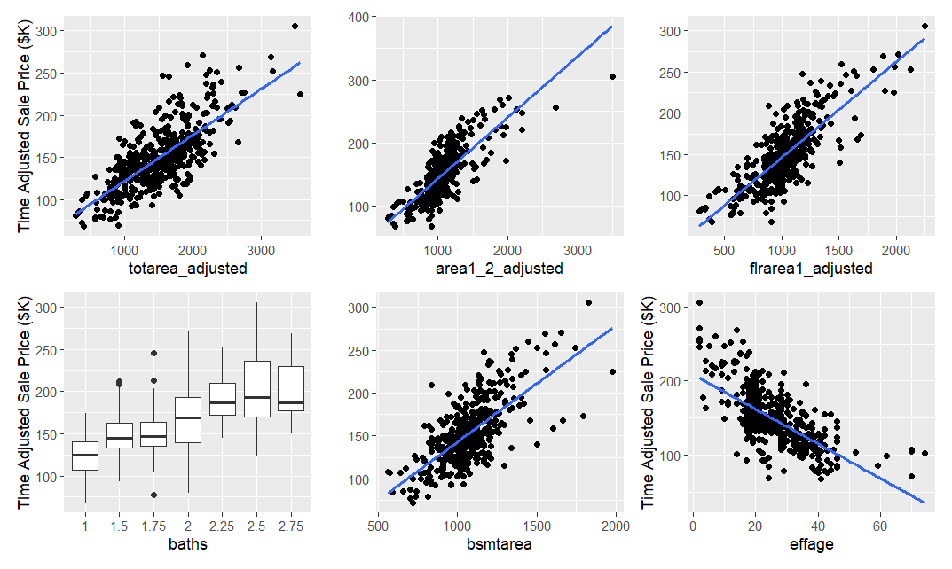
R²=0.43
R²=0.47
R²=0.62
R²=0.62
R²=0.54
Variables to be included and excluded in the model.
Include |  |  | Exclude
familyrm | flrarea2_adjusted | sidewalk | unfinbmt
fireplcs | baseste | totarea_adjusted | corner
flrarea1_adjusted | Heattype | bsmtarea | wooded
bsmtfin_adjusted | splitlvl | totarea_adjusted | slope
crwlarea | lot_size_adjusted | alley | abv_road
area1_2_adjusted | pie_shpe | Bedroom | gar_area_adjusted
conduit | culdesac | Bath | cp_area_adjusted
garagefl | effage |  | carptfl

Note that, however, the following variables have high correlation with each other and only one from each group should be included in the modeling.
Group
1 | flrarea1_adjusted | bsmtarea | area1_2_adjusted | totarea_adjusted
2 | bsmtfin_adjusted | totarea_adjusted
3 | crwlarea | bsmtarea
4 | conduit | alley

The preceding steps provide the necessary data preparation and relationship identification. The next step involves the selection of specific variables for model calibration.

Step 6 – List Variables for Calibration
Results of the previous steps show that the variables with high correlation with time adjusted sale price and those with high correlation with each other. Following the textbook, I am classifying the variables into various groups and fit the model on each to find the best groups of variables. Among those, there are variables that are common between the groups.
familyrm | flrarea2_adjusted | lot_size_adjusted
fireplcs | baseste | pie_shpe
Heattype | effage | culdesac
splitlvl | sidewalk | garagefl
Bedroom | Bath

Besides these common variables, I form the following groups as well, each customized based on the variables with high correlation.

Groups of Variables
Group 1  (19 Variables) | flrarea1_adjusted | bsmtfin_adjusted | crwlarea | alley
Group 2  (18 Variables) | bsmtarea | bsmtfin_adjusted | conduit
Group 3  (18 Variables) | totarea_adjusted | crwlarea | conduit
Group 4  (19 Variables) | area1_2_adjusted | bsmtfin_adjusted | crwlarea | conduit

I fitted four models using the variables from the groups above and compared them in the following table. Based on the results, models with Group 4 variables have the best Adjusted R² and the lowest SSE. I need to check for collinearity among the variables. Rows highlighted in orange indicate variables with VIF values greater than 3.33, suggesting potential multicollinearity.
Group Number | Adjusted_R2 | SSE | F_Statistic | Significance
1 | 0.79 | 287283850 | 96.58 | 0.00
2 | 0.77 | 304138868 | 95.08 | 0.00
3 | 0.78 | 296209197 | 98.33 | 0.00
4 | 0.80 | 274373044 | 102.29 | 0.00

Group 4
Variable | Coefficient |  | Standard_Coefficient |  | t_Statistic |  | Significance |  | VIF
(Intercept) | 30589.436 |  | 0.832 |  | 2.660 |  | 0.008
familyrm | -3713.279 |  | -0.101 |  | -1.877 |  | 0.061 |  | 2.081
flrarea2_adjusted | -9.036 |  | 0.000 |  | -1.132 |  | 0.258 |  | 2.081
lot_size_adjusted | 6.010 |  | 0.000 |  | 3.966 |  | 0.000 |  | 1.331
fireplcs | 3060.934 |  | 0.083 |  | 2.309 |  | 0.021 |  | 1.591
baseste | -4483.907 |  | -0.122 |  | -1.138 |  | 0.256 |  | 1.288
pie_shpe | 5873.225 |  | 0.160 |  | 1.533 |  | 0.126 |  | 1.360
heattype | -75.964 |  | -0.002 |  | -0.122 |  | 0.903 |  | 1.059
effage | -710.294 |  | -0.019 |  | -5.653 |  | 0.000 |  | 2.875
culdesac | 4699.267 |  | 0.128 |  | 1.263 |  | 0.207 |  | 1.371
splitlvl | 6209.205 |  | 0.169 |  | 1.967 |  | 0.050 |  | 1.145
sidewalk | 3181.343 |  | 0.087 |  | 1.128 |  | 0.260 |  | 1.131
garagefl | 8855.042 |  | 0.241 |  | 4.716 |  | 0.000 |  | 1.221
area1_2_adjusted | 50.936 |  | 0.001 |  | 9.744 |  | 0.000 |  | 4.121
bsmtfin_adjusted | 11.051 |  | 0.000 |  | 2.917 |  | 0.004 |  | 2.644
crwlarea | -11.454 |  | 0.000 |  | -3.005 |  | 0.003 |  | 1.245
conduit | 11682.323 |  | 0.318 |  | 4.804 |  | 0.000 |  | 2.303
bedrooms | 3527.746 |  | 0.096 |  | 1.905 |  | 0.057 |  | 1.416
baths | 10064.459 |  | 0.274 |  | 4.415 |  | 0.000 |  | 2.179

The selected model presents a few issues. area1_2_adjusted shows VIF values greater than 3.33, indicating potential multicollinearity with other variables. This is expected since area1_2_adjusted are correlated with effage, leading to a high VIF. However, due to the importance of area1_2_adjusted, I keep it for now and will revisit its inclusion during model calibration.
Lastly, I am analyzing the coefficients to ensure they make sense. familyrm has a negative coefficient, which may not align with expectations. However, after examining the large positive coefficient for bedroom, it appears that houses with more bedrooms are preferred over those with larger family rooms, as more bedrooms make the house more functional. The negative coefficient for flrarea2_adjusted is also unexpected, but since its effect is not statistically significant, we can leave it as is and expect this issue to be addressed during the stepwise approach. Similarly, the variable baseste, which indicates the presence of a basement, shows a negative coefficient, but its effect is also not significant and will be reviewed further in the stepwise analysis. To facilitate model training and validation, the dataset was partitioned into training and testing subsets. The methodology for this partitioning is described in the following section.

TEST/MODEL Split
Our selected model has 26 variables, requiring at least 130 sales to calibrate the parameters. This is significantly lower than the number of sales available in our dataset. I allocated 320 sales for model training and reserved the remaining 146 for testing (a 70/30 split). The original dataset includes a random column for sorting sales. I used this column to sort the data and selected the first 320 sales for training (Step 7) and the last 146 for testing (Step 8).
With the training dataset established, the model parameters require calibration. The following section details the stepwise approach utilized for this calibration.

Step 7 – Model Calibration
I use stepwise approach to calibrate the parameters; the model’s summary for each step is included in Appendix (Table A.2) and the model summary with the coefficients are included here (Table A.3).
Final Model ANOVA table
 | SSE | df | Mean SSE | F | Sig
Regression | 2.93659E+11 | 14 | 20975655466 | 74.04979 | 0.00
Residuals | 86395588388 | 305 | 283264224.2
Total | 3.80055E+11 | 319

Final Model Coefficient
Variable | Coefficient | Standard_Coefficient | t_Statistic | Significance | VIF
(Intercept) | 35582.070 | 1.031 | 2.605 | 0.010
familyrm | -4334.855 | -0.126 | -1.751 | 0.081 | 2.181
lot_size_adjusted | 5.032 | 0.000 | 2.642 | 0.009 | 1.314
fireplcs | 3378.705 | 0.098 | 2.135 | 0.034 | 1.477
baseste | -8409.833 | -0.244 | -1.620 | 0.106 | 1.274
pie_shpe | 10423.479 | 0.302 | 2.265 | 0.024 | 1.203
effage | -536.207 | -0.016 | -3.485 | 0.001 | 2.451
splitlvl | 6654.107 | 0.193 | 1.627 | 0.105 | 1.158
sidewalk | 6965.045 | 0.202 | 1.865 | 0.063 | 1.093
garagefl | 6417.647 | 0.186 | 2.765 | 0.006 | 1.188
area1_2_adjusted | 56.863 | 0.002 | 11.162 | 0.000 | 2.150
bsmtfin_adjusted | 15.497 | 0.000 | 3.329 | 0.001 | 2.488
crwlarea | -12.359 | 0.000 | -2.536 | 0.012 | 1.253
conduit | 13379.662 | 0.388 | 4.742 | 0.000 | 2.054
baths | 8769.237 | 0.254 | 3.120 | 0.002 | 2.017

Excluded Variable
Variable | Coefficient | Standard_Coefficient | t_Statistic | Significance | VIF
flrarea2_adjusted | -9.036 | 0.000 | -1.132 | 0.258 | 2.081
heattype | -75.964 | -0.002 | -0.122 | 0.903 | 1.059
culdesac | 4699.267 | 0.128 | 1.263 | 0.207 | 1.371
bedrooms | 3527.746 | 0.096 | 1.905 | 0.057 | 1.416

As expected, all the variables that were excluded have t-statistics with significance levels of 21% or higher, meaning they are not statistically significant at the 10% level. Similarly, most of the variables included in the final model after the stepwise selection are significant at the 10% level. However, variables such as baseste and sidewalk are included in the model, even though their t-statistics are slightly below the 10% significance threshold. On the positive side, none of the variables have a VIF greater than 2.5, indicating that the multicollinearity issues discussed in the previous is not the case anymore.
Next, I am performing a Casewise diagnostic test to check for records with standardized residuals greater than 3 or less than -3. No records meeting this criterion were found, indicating that there are no extreme residuals in the model. Table below shows the normalized value for residual and predicted values.
Residuals and Predicted Values
Metric | Min | Max | Mean | Std. Deviation | Count
Predicted Values | 65924.12 | 272930.60 | 147799.40 | 30340.76 | 320
Residuals | -42981.94 | 49403.95 | 0.00 | 16456.99 | 320
Std. Predicted Values | -2.70 | 4.12 | 0.00 | 1.00 | 320
Std. Residuals | -2.64 | 2.99 | 0.00 | 1.00 | 320

Model Summary
R | R² | Adjusted R² | Std. Error of Estimate
0.88 | 0.77 | 0.76 | 16830.46

The negative coefficient for familyrm has already been discussed. Here, I will finalize this step by addressing the variables baseste and crwlarea. Both the presence of a basement (baseste) and crawl areas (crwlarea) came with negative coefficients. It is important to note that the finished basement area (bsmtfin_adjusted) has a positive coefficient, which reflects the desirability of a finished basement. However, the basement may now be correlated with unfinished areas that are less desirable. Similarly, crawl spaces are generally not as desirable because they are less practical compared to finished basements. Therefore, it is not surprising that the effect of crawl spaces is predicted to be negative in the model.
The final model, therefore, is given below:
saleprice_time_adjusted = 35582.070 - 4334.855 (familyrm) + 5.032 (lot_size_adjusted) + 3378.705 (fireplcs) - 8409.833 (baseste) + 10423.479 (pie_shpe) - 536.207 (effage) + 6654.107 (splitlvl) + 6965.045 (sidewalk) + 6417.647 (garagefl) + 56.863 (area1_2_adjusted) + 15.497 (bsmtfin_adjusted) - 12.359 (crwlarea) + 13379.662 (conduit) + 8769.237 (baths)
Ratio Statistics for ASR = Predicted/Time Adjusted Sale Price – Training Data
Mean |  | 1.01
95% Confidence Interval for Mean | Lower Bound | 1.00
 | Upper Bound | 1.03
Median |  | 1.00
95% Confidence Interval for Median | Lower Bound | 0.99
 | Upper Bound | 1.02
 | Actual Coverage | 95.6%
Minimum |  | 0.75
Maximum |  | 1.52
Coefficient of Dispersion |  | 8.9%
The final phase of model development involves a rigorous assessment of the model's predictive performance using the holdout sample. The results of this testing are presented in this section.

Step 8 – Model Testing

Neighborhood Adjustment
As mentioned earlier, I did not include the neighbourhood in the modeling process. Therefore, it is necessary to test if all the neighbourhoods are valuated equally. I am using Kruskal-Wallis test and ratio statistics analysis for this part.
Ranks of ASR for Neighborhoods
Neigh | N | Mean Rank
713 | 55 | 155
715 | 45 | 226
716 | 111 | 151
731 | 20 | 34.2
732 | 5 | 139
734 | 10 | 307
736 | 18 | 206
737 | 56 | 139

Test Statistics for ASR - Neighborhood
Kruskal-Wallis H | 93.95
df | 7
Asymp Sig. | 0.000

The tables above show that the adjustment for neighborhood is required as the p-value for Kruskal Wallis test is below out 5% threshold. To find out the adjustment ratio, I am checking the ratio statistics for ASR.

Ratio Statistics for ASR
Neigh | Median | Lower Bound | Upper Bound | Actual Coverage | Minimum | Maximum | COD
713 | 0.99 | 0.96 | 1.03 | 95.6 | 0.78 | 1.32 | 8.56
715 | 1.08 | 1.05 | 1.13 | 94.6 | 0.86 | 1.38 | 7.45
716 | 1 | 0.99 | 1.02 | 95.3 | 0.82 | 1.22 | 5.95
731 | 0.83 | 0.78 | 0.87 | 92.2 | 0.75 | 0.98 | 7.59
734 | 1.31 | 1.2 | 1.35 | 93.5 | 1.11 | 1.52 | 7.16
736 | 1.09 | 0.97 | 1.1 | 93.6 | 0.89 | 1.24 | 6.65
737 | 0.99 | 0.96 | 1.01 | 93.7 | 0.76 | 1.22 | 7.94

Table above shows that neighbourhood 715, 731, and 734 need adjustment as the confidence interval for median does not include 1.00. I adjust the prediction for neighbourhood 715 by 1/1.08, neighborhood 731 by 1/0.83, and neighborhood 734 by 1.31. I repeat the ratio statistics after adjustment in the neighborhood to ensure adjustment is done correctly. The ratio statistics after adjustment is included in the Appendix (Table A.4). Similarly, I am doing more adjustment based on Manual Class, and the ratio statistics before and after the adjustment are available in the Appendix (Table A.5 – A.6). Finally, I check for bedrooms, heattype, culdesac, and alley as I removed them during the stepwise process and their Kruskal-Wallis statistics are all above 5% threshold which shows no further adjustment is needed (Table A.7).

Evaluating Model Quality Using Holdout Sample
In this section, I am testing the model obtained in the previous section using the TEST data. First, let’s recreate the ratio statistics for the testing data. The ratio statistics show that the mean and median are very close to 1.00 and the confidence interval for both include 1.00. The COD is also withing the IAAO standard of 5 to 10%, which is acceptable.
Ratio Statistics for ASR = Predicted/Time Adjusted Sale Price – Testing Data
Mean |  | 1.00
95% Confidence Interval for Mean | Lower Bound | 0.98
 | Upper Bound | 1.02
Median |  | 1.01
95% Confidence Interval for Median | Lower Bound | 0.99
 | Upper Bound | 1.02
 | Actual Coverage | 95.3%
Minimum |  | 0.67
Maximum |  | 1.34
Coefficient of Dispersion |  | 8.5%

Evaluating Model Quality Using Entire Dataset
Ratio Statistics for ASR = Predicted/Time Adjusted Sale Price – Entire Dataset
Mean |  | 1.01
95% Confidence Interval for Mean | Lower Bound | 1.00
 | Upper Bound | 1.02
Median |  | 1.00
95% Confidence Interval for Median | Lower Bound | 1.00
 | Upper Bound | 1.01
 | Actual Coverage | 94.82%
Minimum |  | 0.72
Maximum |  | 1.4
Coefficient of Dispersion |  | 7.6%

Again, the ratio statistics for entire dataset shows that the COD and median ASR is within IAAO threshold.

Modeling ASR
Next process for testing the model is to ensure that the adjusted ASR does not have high correlation with any of the independent variables I used I the model. That is to show there is no bias for ASR with respect to the independent variables. For that purpose, I fit a model with adjusted ASR as the response variable and the same independent variable as the model above. The model’s coefficients are given below.
Variable | Coefficient | Standard_Coefficient | t_Statistic | Significance | VIF
(Intercept) | 0.987 | 10.016 | 14.924 | 0.000
familyrm | -0.010 | -0.101 | -0.874 | 0.382 | 2.081
flrarea2_adjusted | 0.000 | 0.001 | 2.616 | 0.009 | 2.081
lot_size_adjusted | 0.000 | 0.000 | -0.973 | 0.331 | 1.331
fireplcs | -0.007 | -0.067 | -0.870 | 0.385 | 1.591
baseste | -0.035 | -0.352 | -1.530 | 0.127 | 1.288
pie_shpe | 0.033 | 0.334 | 1.494 | 0.136 | 1.360
heattype | -0.002 | -0.017 | -0.464 | 0.643 | 1.059
effage | 0.003 | 0.027 | 3.646 | 0.000 | 2.875
culdesac | -0.022 | -0.218 | -1.007 | 0.315 | 1.371
splitlvl | 0.014 | 0.145 | 0.789 | 0.431 | 1.145
sidewalk | 0.056 | 0.568 | 3.450 | 0.001 | 1.131
garagefl | -0.005 | -0.049 | -0.450 | 0.653 | 1.221
area1_2_adjusted | 0.000 | 0.000 | 0.705 | 0.481 | 4.121
bsmtfin_adjusted | 0.000 | 0.000 | 0.415 | 0.679 | 2.644
crwlarea | 0.000 | 0.000 | -0.288 | 0.773 | 1.245
conduit | 0.034 | 0.349 | 2.459 | 0.014 | 2.303
bedrooms | -0.018 | -0.188 | -1.736 | 0.083 | 1.416
baths | 0.016 | 0.164 | 1.229 | 0.220 | 2.179

There are 4 variables where significantly affect the adjusted ASR and so need to investigate further. Similar to the previous section, I first check if adjustment is needed for conduit and sidewalk in the Appendix. Results show that adjustment for sidewalk is needed which I include the results before and after adjustment in the Appendix (Table A.8 – A.9). Next, I need to check the adjusted ASR with the effage and flrarea2_adjusted to see what is the R². The figures below show that the correlation between the adjusted ASR and effage or floor area 2 is not significant.
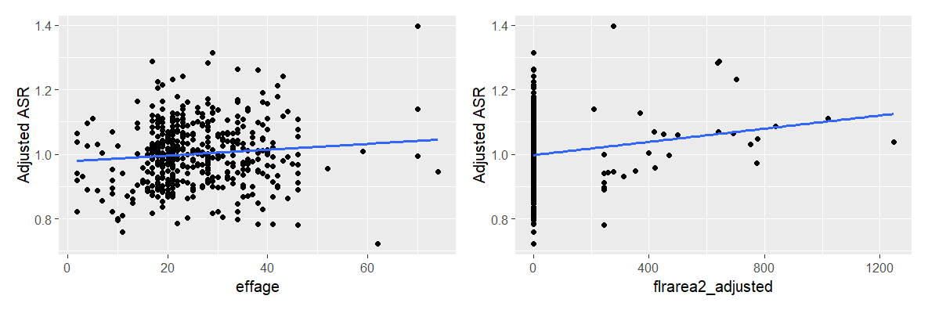
R²=0.02
R²=0.01

Final Check for Neighborhood
As the final check, I do a Kruskal-Wallis test to ensure the adjusted ASR is equally valuated across neighborhood. Table below shows that the significance level of the test is not below 5%, our threshold.
Test Statistics for Adjusted ASR - Neighborhood
Kruskal-Wallis H | 13.8
df | 7
Asymp Sig. | 0.05

Conclusion
The final regression model developed in this analysis demonstrates a reasonable capacity for estimating property values. The model's performance is supported by the ratio study and bias tests, which indicate that the model meets IAAO standards. Specifically, the coefficient of dispersion (COD) for the entire dataset is 7.6%, falling within the acceptable range of 5% to 10%, and the median assessment-to-sales ratio (ASR) is 1.00, demonstrating minimal bias. The model also performs acceptably on the holdout sample, with a COD of 8.5% and mean and median ASR values close to 1.00.
Despite its utility, the cost-based model has limitations. Its accuracy is contingent on the quality and completeness of the input data, and it assumes that past sales reliably predict future market values, which may not always be true. While the model incorporates key property characteristics, it may not capture all factors influencing property values. The model's strengths include its objectivity, consistency, and the use of stepwise regression to minimize multicollinearity and identify significant variables.
To enhance the model, several recommendations are made. These include improving data quality control, continuous market monitoring and model recalibration, exploring the inclusion of additional relevant variables, refining neighborhood-specific adjustments, and ongoing model validation. Addressing these limitations and implementing these recommendations will further strengthen the model's effectiveness as a valuation tool.

Appendix

A.1. Data Description

Building Quality (BQ variables)
- MBMANCLS: Indicates the main building class.
- MBYRBLT: The year the main building was constructed.
- MBEFFYR: The effective year built, considering renovations and depreciation.
- LINMCLS: A scaled version of the main building class
- MBMCLSDV: The percentage deviation from the main building quality class

Building Additive (BA variables)
- BEDROOMS: Number of bedrooms in the property.
- BATHS: Number of bathrooms.
- FAMILYRM: Count of family or recreation rooms.
- FIREPLCS: Number of fireplaces.
- FLRAREA1: Area of the first floor.
- FLRAREA2: Area of the second floor.
- BSMTFIN: Finished basement area.
- CRWLAREA: Crawl space area.
- BMSTAREA: Full-height basement area.
- UNFINBMT: Unfinished basement area.
- AREA1_2: Total area of the first and second floors.
- TOTAREA: Total finished area, including the basement.
- BASESTE: Binary – indicates if there is a basement suite.
- DECKAREACOVERED: Covered deck area.
- DECKAREAUNCOVERED: Uncovered deck area.
- HEATTYPE: The type of heating system, which can influence the property’s desirability and value.

Land Qualitative (LQ variables)
- CORNER: Indicates if the lot is a corner lot.
- WOODED: Indicates if the lot is more wooded than typical lots in the neighbourhood.
- PIE_SHPE: Indicates if the lot is pie shaped.
- SLOPE: Indicates if the lot is sloped.
- ABV_ROAD: Indicates if the lot is above the road level.
- CULDESAC: Indicates if the lot fronts on a cul-de-sac.

Other Building Qualitative and Additive (OQ and OA variables)
- GARAGEFL: Indicates the presence of a garage.
- CARPTFL: Indicates the presence of a carport.
- CP_AREA: Total area of the carport.
- GAR_AREA: Total area of the garage.

A.2. Variable Transformation
Table A 1. Mapping between Manual Class and Scaled Numeric Value
Garage/Carport Manual Class (factors) | Scaled Numeric Value
910/911 | 0.450
920/921 | 1.000
930/931 | 1.200
940/941 | 1.420

Variable Examination
Fig A 1. Variable Correlation with Response Variable – Moderate Correlation
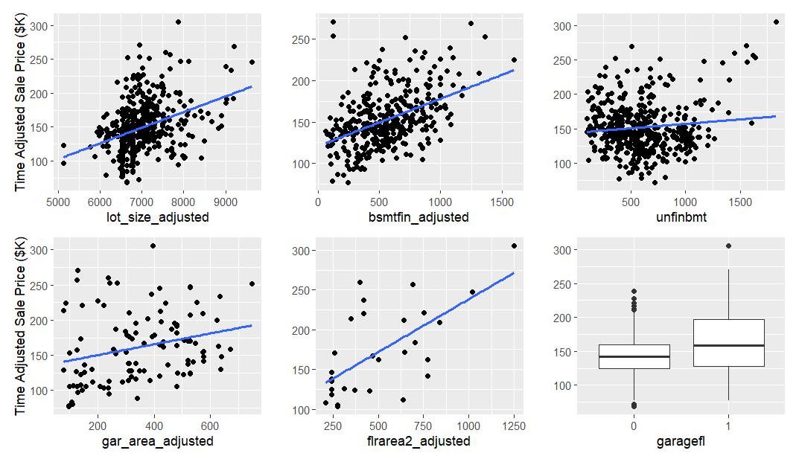
R²=0.01
R²=0.42
R²=0.14
R²=0.01
R²=0.21

Fig A 2. Variable Correlation with Response Variable – Moderate Correlation
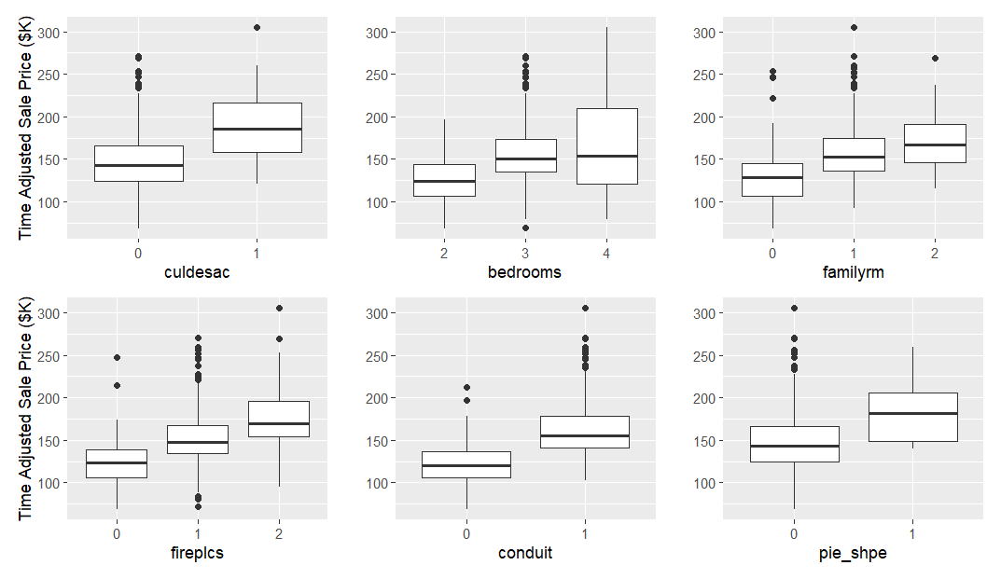
R²=0.33
Fig A 3 Variable Correlation with Response Variable – Low Correlation
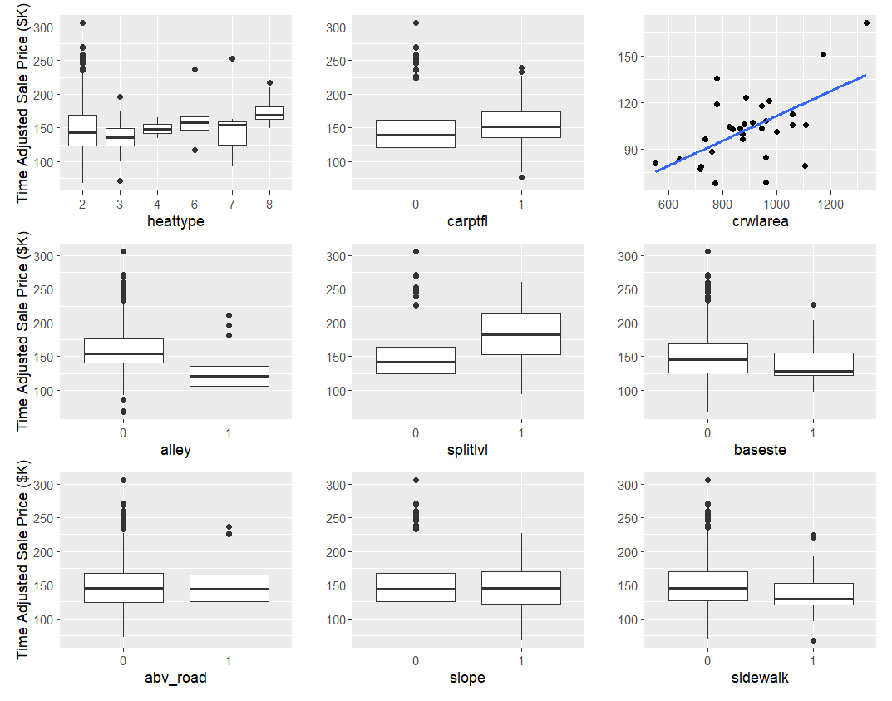

Fig A 4. Variable Correlation with Response Variable – Low Correlation
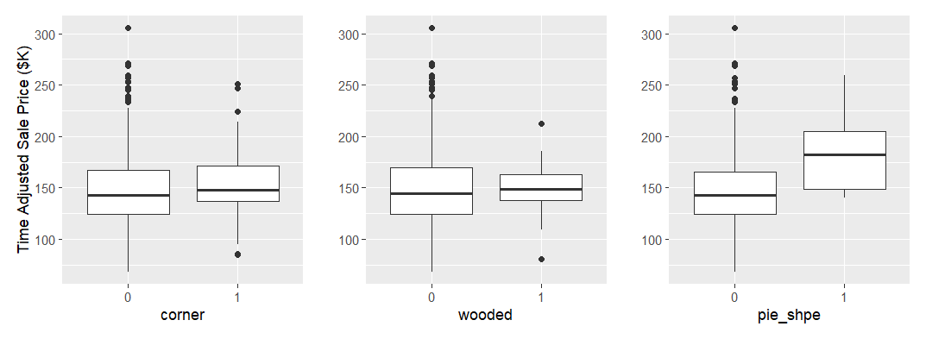

A.3. Step 7 – Model Calibration

Stepwise Regression
Table A 2 – Model Summary for the Models between Steps
Model | R | R Squared | Adjusted R Squared | Std. Error of the Estimate | F Statistic
Model1 | 0.897 | 0.805 | 0.797 | 16564.210 | 102.295
Model2 | 0.897 | 0.805 | 0.797 | 16545.990 | 108.550
Model3 | 0.897 | 0.804 | 0.797 | 16551.060 | 115.184
Model4 | 0.896 | 0.804 | 0.797 | 16557.110 | 122.684
Model5 | 0.896 | 0.802 | 0.796 | 16601.870 | 130.495

Table A 3 Model Variables for the Models between Steps
Model | Predictors:
Model1 | familyrm, flrarea2_adjusted, lot_size_adjusted, fireplcs, baseste, pie_shpe, heattype, effage, culdesac, splitlvl, sidewalk, garagefl, area1_2_adjusted, bsmtfin_adjusted, crwlarea, conduit, bedrooms, baths
Model2 | familyrm, flrarea2_adjusted, lot_size_adjusted, fireplcs, baseste, pie_shpe, effage, culdesac, splitlvl, sidewalk, garagefl, area1_2_adjusted, bsmtfin_adjusted, crwlarea, conduit, bedrooms, baths
Model3 | familyrm, lot_size_adjusted, fireplcs, baseste, pie_shpe, effage, culdesac, splitlvl, sidewalk, garagefl, area1_2_adjusted, bsmtfin_adjusted, crwlarea, conduit, bedrooms, baths
Model4 | familyrm, lot_size_adjusted, fireplcs, baseste, pie_shpe, effage, splitlvl, sidewalk, garagefl, area1_2_adjusted, bsmtfin_adjusted, crwlarea, conduit, bedrooms, baths
Model5 | familyrm, lot_size_adjusted, fireplcs, baseste, pie_shpe, effage, splitlvl, sidewalk, garagefl, area1_2_adjusted, bsmtfin_adjusted, crwlarea, conduit, baths

A.4. Step 8 – Model Testing

Model Adjustment
Table A 4. Ratio Statistics for ASR after Adjustment
Neigh | Median | Lower Bound | Upper Bound | Actual Coverage | Minimum | Maximum | COD
713 | 0.99 | 0.96 | 1.03 | 95.6 | 0.78 | 1.32 | 8.56
715 | 1 | 0.97 | 1.05 | 94.6 | 0.8 | 1.28 | 7.45
716 | 1 | 0.99 | 1.02 | 95.3 | 0.82 | 1.22 | 5.95
731 | 1 | 0.94 | 1.05 | 92.2 | 0.9 | 1.18 | 7.59
734 | 1 | 0.92 | 1.03 | 93.5 | 0.85 | 1.16 | 7.16
736 | 1.09 | 0.97 | 1.1 | 93.6 | 0.89 | 1.24 | 6.65
737 | 0.99 | 0.96 | 1.01 | 93.7 | 0.76 | 1.22 | 7.94

Table A 5. Ratio Statistics for ASR before Manual Class Adjustment
Manual Class | Median | Lower Bound | Upper Bound | Minimum | Maximum | COD
40 | 0.92 | 0.85 | 0.93 | 0.85 | 0.93 | 1.95
51 | 0.85 | 0.85 | 0.85 | 0.85 | 0.85 | 0
80 | 1.02 | 0.98 | 1.09 | 0.91 | 1.37 | 8.69
81 | 0.94 | 0.78 | 1.13 | 0.78 | 1.13 | 7.58
90 | 1 | 1 | 1.02 | 0.76 | 1.24 | 7.05
92 | 1.05 | 0.97 | 1.28 | 0.97 | 1.28 | 7.18
140 | 1 | 0.98 | 1.01 | 0.79 | 1.22 | 6.73
142 | 0.91 | 0.86 | 0.97 | 0.86 | 0.97 | 4.44
145 | 0.93 | 0.82 | 1.03 | 0.82 | 1.03 | 6.08

Table A 6. Ratio Statistics for ASR after Manual Class Adjustment
Manual Class | Median | Lower Bound | Upper Bound | Minimum | Maximum | COD
40 | 1.01 | 0.92 | 1.01 | 0.92 | 1.01 | 1.95
51 | 1 | 1 | 1 | 1 | 1 | 0
80 | 0.98 | 0.94 | 1.05 | 0.87 | 1.32 | 8.69
81 | 0.94 | 0.78 | 1.13 | 0.78 | 1.13 | 7.58
90 | 1 | 1 | 1.02 | 0.76 | 1.24 | 7.05
92 | 1.05 | 0.97 | 1.28 | 0.97 | 1.28 | 7.18
140 | 1 | 0.98 | 1.01 | 0.79 | 1.22 | 6.73
142 | 1 | 0.95 | 1.07 | 0.95 | 1.07 | 4.44
145 | 0.93 | 0.82 | 1.03 | 0.82 | 1.03 | 6.08

Table A 7. No Adjustment for heattype, bedroom, culdesac, and conduit
 | heattype | bedroom | culdesac | alley | conduit
Kruskal-Wallis H | 4.52 | 5.58 | 0.14 | 0.19 | 0.60
df | 5 | 2 | 1 | 1 | 1
Asymp Sig. | 0.48 | 0.07 | 0.71 | 0.66 | 0.43

Table A 8. Ratio Statistics for ASR before sidewalk Adjustment
Sidewalk | Median | Lower Bound | Upper Bound | Minimum | Maximum | COD
0 | 1 | 0.99 | 1.01 | 0.72 | 1.4 | 7.41
1 | 1.06 | 1 | 1.1 | 0.85 | 1.34 | 8.02

Table A 9. Ratio Statistics for ASR after sidewalk Adjustment
Sidewalk | Median | Lower Bound | Upper Bound | Minimum | Maximum | COD
0 | 1 | 0.99 | 1.01 | 0.72 | 1.4 | 7.41
1 | 1 | 0.95 | 1.04 | 0.8 | 1.26 | 8.02

Syntax (in R)
library(tidyverse)
library(readr)
library(haven)
library(magrittr)
library(car)
library(patchwork)
library(corrplot)
library(rlang)
library(broom)
rm(list = ls())

data <- read_sav("Data/BUSI 444 Term 2 Case Study 466 Marilu Project 2.sav")

data%<>%mutate(SAR = saleprice/totalval)

SAR_month <- data%>%group_by(month)%>%summarise(SAR = mean(SAR), .groups = 'drop')
SAR_July_1<-(SAR_month[SAR_month['month']==6,'SAR'] + SAR_month[SAR_month['month']==7,'SAR'])$SAR/2
SAR_month%<>%mutate(Factor = SAR_July_1 / SAR)

data%<>%mutate(
saleprice_time_adjusted = case_when(
month == 3 ~ saleprice * 1.013,
month == 4 ~ saleprice * 0.999,
month == 5 ~ saleprice * 1.001,
month == 6 ~ saleprice * 1.009,
month == 7 ~ saleprice * 0.991,
month == 8 ~ saleprice * 1.011,
month == 9 ~ saleprice * 0.977,
month == 10 ~ saleprice * 0.979
)
)

kruskal.test(data$saleprice_time_adjusted, data$month)

View(SAR_month)

n<-nrow(data)
lower_index <- qbinom(0.05 / 2, n, 0.5)
upper_index <- qbinom(1- 0.05/2, n, 0.5)

data%<>%mutate(landsize_per_square = landval/lot_size)
data%<>% mutate(sizefact_eq = (mean(lot_size)/lot_size)^(1.2/2))
data%<>% mutate(sizefact = landsize_per_square/median(landsize_per_square))

data%>%ggplot(aes(x = lot_size/10000, y = sizefact))+ geom_point()+
geom_line(aes(x=lot_size/10000, y= sizefact_eq), size = 1, color = 'red')+
labs(x = 'Lot area in sq feet (divided by 10,000)', y= 'Size Factor',
title = 'Size Factor Vs. Lot Area')

# epsilon_values <- seq(0.5, 2, by=0.1) # Try values between 0.5 and 2
# errors <- numeric(length(epsilon_values))
#
# for (i in seq_along(epsilon_values)) {
# e <- epsilon_values[i]
# adjusted_size <- data$sizefact_eq^(e/2) # Apply exponent
# errors[i] <- sum((adjusted_size - data$sizefact)^2) # Replace expected_values with real data
# }
# best_epsilon <- epsilon_values[which.min(errors)]
# print(best_epsilon)

## Fitting Quadratic, Cubic, and Power models to the data
power_model <- lm(log(sizefact) ~ log(lot_size/10000), data = data)

a <- exp(coef(power_model)[1]) # Intercept
b <- coef(power_model)[2] # Slope
data <- data %>%
mutate(adjs_fac = a * ((lot_size/10000)^b),
lot_size_adjusted = lot_size * adjs_fac)

## Manual Classes
data %<>%
mutate(
linmcls_cp = case_when(
cp_mancl %in% c(910,911) ~ 0.450,
cp_mancl %in% c(920,921) ~ 1.000,
cp_mancl %in% c(930,931) ~ 1.200,
cp_mancl %in% c(940,941) ~ 1.420,
TRUE ~ 1.000
),
linmcls_gr = case_when(
gr_mancl %in% c(910,911) ~ 0.450,
gr_mancl %in% c(920,921) ~ 1.000,
gr_mancl %in% c(930,931) ~ 1.200,
gr_mancl %in% c(940,941) ~ 1.420,
TRUE ~ 1.000
))

rank_no <- function (data, x) {
x <- enquo(x)
output <- rbind(
data%>%mutate(Rank = rank(!!x), value = corner)%>%group_by(value)%>%
summarise(count = n(), MeanRank = mean(Rank)),
data%>%mutate(Rank = rank(!!x), value = culdesac)%>%group_by(value)%>%
summarise(count = n(), MeanRank = mean(Rank)),
data%>%mutate(Rank = rank(!!x), value = alley)%>%group_by(value)%>%
summarise(count = n(), MeanRank = mean(Rank)),
data%>%mutate(Rank = rank(!!x), value = wooded)%>%group_by(value)%>%
summarise(count = n(), MeanRank = mean(Rank)),
data%>%mutate(Rank = rank(!!x), value = pie_shpe)%>%group_by(value)%>%
summarise(count = n(), MeanRank = mean(Rank)),
data%>%mutate(Rank = rank(!!x), value = slope)%>%group_by(value)%>%
summarise(count = n(), MeanRank = mean(Rank)),
data%>%mutate(Rank = rank(!!x), value = abv_road)%>%group_by(value)%>%
summarise(count = n(), MeanRank = mean(Rank)))
return(output)
}

ratio_statistics <- function (data, x, y) {
x <- enquo(x)
y <- enquo(y)

output <- round(cbind(data%>%
arrange(!!x)%>%
group_by(!!y, .drop = FALSE)%>%reframe(
Mean = mean(!!x),
LB_mean = mean(!!x) - 1.96 * sd(!!x)/sqrt(n()),
UB_mean = mean(!!x) + 1.96 * sd(!!x)/sqrt(n()),
Median = median(!!x),
Min = min(!!x),
Max = max(!!x),
COD = (mean(abs(!!x-median(!!x)))/median(!!x)) * 100,
CV = sd(!!x)/mean(!!x)*100,
LB_mode = (!!x)[max(qbinom(0.05 / 2, n(), 0.5),1)],
UB_mode = (!!x)[max(qbinom(1-0.05 / 2, n(), 0.5),1)],
Actual_coverage = (pbinom(max(qbinom(1-0.05 / 2, n(), 0.5),1), n(), 0.5) -
pbinom(max(qbinom(0.05 / 2, n(), 0.5),1), n(), 0.5))*100)),2)
return (output)
}

### EDA

data%<>%mutate(flrarea1_adjusted = linmcls * flrarea1,
flrarea2_adjusted = linmcls * flrarea2,
area1_2_adjusted = linmcls * area1_2,
totarea_adjusted = linmcls * totarea,
bsmtfin_adjusted = linmcls * bsmtfin,
gar_area_adjusted = linmcls_gr * gar_area,
cp_area_adjusted = linmcls_cp * cp_area,
effage = 2017 - mbeffyr)%>%
mutate(neigh_713 = ifelse(neigh == 713, 1,0),
neigh_715 = ifelse(neigh == 715, 1,0),
neigh_731 = ifelse(neigh == 731, 1,0),
neigh_732 = ifelse(neigh == 732, 1,0),
neigh_734 = ifelse(neigh == 734, 1,0),
neigh_736 = ifelse(neigh == 736, 1,0),
neigh_737 = ifelse(neigh == 737, 1,0))

data_model <- data%>%select(bedrooms, baths, familyrm, fireplcs, flrarea1_adjusted,flrarea2_adjusted,
bsmtfin_adjusted, crwlarea, bsmtarea, unfinbmt, area1_2_adjusted,totarea_adjusted, baseste,
heattype, splitlvl,lot_size_adjusted,
corner, wooded, pie_shpe, slope, abv_road, culdesac,effage,
conduit, alley, sidewalk, gar_area_adjusted, garagefl, cp_area_adjusted, carptfl,
saleprice_time_adjusted, neigh_713, neigh_715, neigh_731, neigh_732, neigh_734, neigh_736, neigh_737)

View(cor(data_model))

data%>%group_by(neigh)%>%summarise(N = n(),
Mean = mean(saleprice_time_adjusted),
std.Deviation = sd(saleprice_time_adjusted),
.groups = 'drop')

scatter_plots <- function (data, x, y_label){
x <- enquo(x)
fig <- data%>%ggplot(aes(x= !!x, y= saleprice_time_adjusted/1000))+geom_point()+
geom_smooth(method = 'lm', se = FALSE)

if (y_label) {
fig <- fig + labs(y = "Time Adjusted Sale Price ($K)")
} else {
fig <- fig + labs(y = "")
}

formula <- new_formula(
lhs = quote(saleprice_time_adjusted),
rhs = get_expr(x),
env = caller_env()
)

r_squared <- summary(lm(formula, data = data))$r.squared
return (list(figure = fig, r_sq = r_squared))
}

box_plots <- function (data, x, y_label){
x <- enquo(x)

data %<>%mutate(!!x := as.factor(!!x))

fig <- data%>%
ggplot(aes(x= !!x, y= saleprice_time_adjusted/1000))+geom_boxplot()

if (y_label) {
fig <- fig + labs(y = "Time Adjusted Sale Price ($K)")
} else {
fig <- fig + labs(y = "")
}

return (list(figure = fig))
}

### Descriptive Analysis

descriptive_analyzis <- sapply(X= names(data_model), FUN = function (x) {

return(list( Min = min(data_model[[x]], na.rm = TRUE),
Max = max(data_model[[x]], na.rm = TRUE),
Mean = mean(data_model[[x]], na.rm = TRUE),
Median = median (data_model[[x]], na.rm = TRUE)
))

})

View(as.data.frame(descriptive_analyzis)%>%t%>%as.data.frame()%>%filter(Max > 10))

Descriptive_cols <- as.data.frame(descriptive_analyzis)%>%t%>%as.data.frame()%>%filter(Max <= 10)

frequency_table <- lapply(row.names(Descriptive_cols), function(x) {
# Summarise the count for each group in the column
result <- data_model %>%
group_by(!!sym(x)) %>%
summarise(count = n(), .groups = 'drop')
} )

## Fixing heattype

data%<>%mutate(heattype = case_when(
heattype == 1 ~ 2,
heattype == 5 ~ 6,
TRUE ~ heattype
))

## Effective Age
effective_year_plot <- scatter_plots(data, effage, TRUE)$figure
effective_year_r_sq <- scatter_plots(data, effage, TRUE)$r_sq

alley_plot <- box_plots(data, alley, TRUE)$figure

## Crawl Area
crawl__plot <- scatter_plots(data%>%filter(crwlarea>0), crwlarea, TRUE)$figure
crawl_r_sq <- scatter_plots(data%>%filter(crwlarea>0), crwlarea, TRUE)$r_sq

## Side Walk

Side_walk <- box_plots(data, sidewalk, FALSE)$figure

## Basement Presence
Bastement_presence <- box_plots(data, baseste, FALSE)$figure

## Above Road

Above_rd <- box_plots(data, abv_road, TRUE)$figure

## Slope

Slope <- box_plots(data, slope, FALSE)$figure

## Wooden

Wooded <- box_plots(data, wooded, FALSE)$figure

## Corner

Corner <- box_plots(data, corner, TRUE)$figure

## Heattype

Heat_type <- box_plots(data, heattype, TRUE)$figure
## Carport Presence

Carport_presence <- box_plots(data, carptfl, FALSE)$figure
## Crawl Area

Crawl_area__plot <- scatter_plots(data%>%filter(crwlarea>0), crwlarea, FALSE)$figure
Crawl_area_r_sq <- scatter_plots(data%>%filter(crwlarea>0), crwlarea, TRUE)$r_sq

## Carport Area

Carport_area__plot <- scatter_plots(data%>%filter(cp_area_adjusted>0), cp_area_adjusted, FALSE)$figure
Carport_area_r_sq <- scatter_plots(data%>%filter(cp_area_adjusted>0), cp_area_adjusted, TRUE)$r_sq

## Unfinished Basement

unfinished_area_plot <- scatter_plots(data%>%filter(unfinbmt>0), unfinbmt, FALSE)$figure
unfinished_area_r_sq <- scatter_plots(data%>%filter(unfinbmt>0), unfinbmt, TRUE)$r_sq

## Pie_shape

Pie_shape <- box_plots(data, pie_shpe, FALSE)$figure

## Garage Area

gar_area_plot <- scatter_plots(data%>%filter(gar_area_adjusted>0), gar_area_adjusted, TRUE)$figure
gar_area_r_sq <- scatter_plots(data%>%filter(gar_area_adjusted>0), gar_area_adjusted, TRUE)$r_sq

## Floor Area 2

floor_2_plot <- scatter_plots(data%>%filter(flrarea2_adjusted>0), flrarea2_adjusted, FALSE)$figure
floor_2_r_sq <- scatter_plots(data%>%filter(flrarea2_adjusted>0), flrarea2_adjusted, TRUE)$r_sq

## Garage Presence

Garage_presence <- box_plots(data, garagefl, FALSE)$figure

## Split-level Presence

Split_presence <- box_plots(data, splitlvl, FALSE)$figure
## Culdesac Presence

Culdesac_presence <- box_plots(data, culdesac, TRUE)$figure
## Bedrooms

Bedrooms <- box_plots(data, bedrooms, FALSE)$figure
## Lot Size

lot_plot <- scatter_plots(data%>%filter(lot_size_adjusted>0), lot_size_adjusted, TRUE)$figure
lot_r_sq <- scatter_plots(data%>%filter(lot_size_adjusted>0), lot_size_adjusted, TRUE)$r_sq

## FamilyRoom

Family_room <- box_plots(data, familyrm, FALSE)$figure

## Basement Finished

Basement_plot <- scatter_plots(data%>%filter(bsmtfin_adjusted>0), bsmtfin_adjusted, FALSE)$figure
Basement_r_sq <- scatter_plots(data%>%filter(bsmtfin_adjusted>0), bsmtfin_adjusted, FALSE)$r_sq

## Fireplcs

Fireplcs <- box_plots(data, fireplcs, TRUE)$figure

## Conduits

Conduits <- box_plots(data, conduit, FALSE)$figure

## Basement Area

Basement_area_plot <- scatter_plots(data%>%filter(bsmtarea>0), bsmtarea, FALSE)$figure
Basement_area_r_sq <- scatter_plots(data%>%filter(bsmtarea>0), bsmtarea, TRUE)$r_sq

## Baths

Bath_plot <- box_plots(data, baths , TRUE)$figure
## Total Area

Total_area_plot <- scatter_plots(data%>%filter(totarea_adjusted>0), totarea_adjusted, TRUE)$figure
Total_area_r_sq <- scatter_plots(data%>%filter(totarea_adjusted>0), totarea_adjusted, TRUE)$r_sq

## Area_1_2

Area_1_2_plot <- scatter_plots(data%>%filter(area1_2_adjusted>0), area1_2_adjusted, FALSE)$figure
Area_1_2_r_sq <- scatter_plots(data%>%filter(area1_2_adjusted>0), area1_2_adjusted, TRUE)$r_sq

## Floor Area_1

Floor_1_plot <- scatter_plots(data%>%filter(flrarea1_adjusted>0), flrarea1_adjusted, FALSE)$figure
Floor_1_r_sq <- scatter_plots(data%>%filter(flrarea1_adjusted>0), flrarea1_adjusted, TRUE)$r_sq

## Green

(Total_area_plot | Area_1_2_plot | Floor_1_plot) /
(Bath_plot | Basement_area_plot | effective_year_plot)

Total_area_r_sq
Area_1_2_r_sq
Floor_1_r_sq
Basement_area_r_sq
effective_year_r_sq

box_plots(data, neigh, TRUE)$figure

## Yellow

(Culdesac_presence | Bedrooms | Family_room)/
(Fireplcs | Conduits |Pie_shape)

(lot_plot | Basement_plot | unfinished_area_plot)/
(gar_area_plot | floor_2_plot | Garage_presence)

lot_r_sq
Basement_r_sq
unfinished_area_r_sq
gar_area_r_sq
floor_2_r_sq

Basement_r_sq
crawl_r_sq

Corner | Wooded | Pie_shape
## White

(Heat_type | Carport_presence | Crawl_area__plot)/
(alley_plot | Split_presence |Bastement_presence)/
(Above_rd | Slope | Side_walk)

Carport_area_r_sq
Crawl_area_r_sq

## Data Model
data_model <- data%>%select(bedrooms, baths, familyrm, fireplcs, flrarea1_adjusted,flrarea2_adjusted,
bsmtfin_adjusted, crwlarea, bsmtarea, unfinbmt, area1_2_adjusted,totarea_adjusted, baseste,
heattype, splitlvl,lot_size_adjusted,
corner, wooded, pie_shpe, slope, abv_road, culdesac,effage,
conduit, alley, sidewalk, gar_area_adjusted, garagefl, cp_area_adjusted, carptfl,
neigh,
saleprice_time_adjusted)

data_group_1 <- data_model%>% select(familyrm, flrarea2_adjusted, lot_size_adjusted,
fireplcs, baseste, pie_shpe,
heattype, effage, culdesac,
splitlvl, sidewalk, garagefl,
saleprice_time_adjusted,
flrarea1_adjusted, bsmtfin_adjusted, crwlarea, alley,
bedrooms, baths)

model_group_1 <- lm(saleprice_time_adjusted ~ ., data = data_group_1)

data_group_2 <- data_model%>% select(familyrm, flrarea2_adjusted, lot_size_adjusted,
fireplcs, baseste, pie_shpe,
heattype, effage, culdesac,
splitlvl, sidewalk, garagefl,
saleprice_time_adjusted,
bsmtarea, bsmtfin_adjusted, conduit,
bedrooms, baths)

model_group_2 <- lm(saleprice_time_adjusted ~ ., data = data_group_2)

data_group_3 <- data_model%>% select(familyrm, flrarea2_adjusted, lot_size_adjusted,
fireplcs, baseste, pie_shpe,
heattype, effage, culdesac,
splitlvl, sidewalk, garagefl,
saleprice_time_adjusted,
totarea_adjusted, crwlarea, conduit,
bedrooms, baths)
model_group_3 <- lm(saleprice_time_adjusted ~ ., data = data_group_3)

data_group_4 <- data_model%>% select(familyrm, flrarea2_adjusted, lot_size_adjusted,
fireplcs, baseste, pie_shpe,
heattype, effage, culdesac,
splitlvl, sidewalk, garagefl,
saleprice_time_adjusted,
area1_2_adjusted, bsmtfin_adjusted , crwlarea ,conduit,
bedrooms, baths)

model_group_4 <- lm(saleprice_time_adjusted ~ ., data = data_group_4)

model_names <- paste0("model_group_", 1:4)
adjusted_r2 <- c()
mean_sse <- c()
f_stat <- c()
p_value <- c()

# Loop through each model and extract metrics
for (i in 1:4) {
# Get the model dynamically
model <- get(model_names[i])
model_summary <- summary(model)

# Extract residual sum of squares (SSE)
sse <- sum(model_summary$residuals^2)

# Residual degrees of freedom (df)
df_residual <- model_summary$df[2]

# Calculate Mean SSE (MSE)
mean_sse[i] <- sse / df_residual

# Extract other metrics
adjusted_r2[i] <- model_summary$adj.r.squared
f_stat[i] <- model_summary$fstatistic[1]
p_value[i] <- pf(model_summary$fstatistic[1],
model_summary$fstatistic[2],
model_summary$fstatistic[3],
lower.tail = FALSE)
}

# Create the final data frame
results_table <- data.frame(
Group = model_names,
Adjusted_R2 = adjusted_r2,
Mean_SSE = mean_sse,
F_Statistic = f_stat,
Significance = p_value
)

print(results_table)

model <- model_group_4
model_summary <- summary(model)

# Extract coefficients
coefficients_table <- as.data.frame(model_summary$coefficients)

# Create base table
result_table <- data.frame(
Variable = rownames(coefficients_table),
Coefficient = coefficients_table$Estimate,
Standard_Coefficient = coefficients_table$Estimate / sd(model$model[[1]]), # Standardized Coefficient
t_Statistic = coefficients_table$`t value`,
Significance = coefficients_table$`Pr(>|t|)`
)

# Calculate VIF and Tolerance
vif_values <- vif(model)
tolerance <- 1 / vif_values

# Add VIF and Tolerance to the table
result_table$Tolerance <- c(NA, tolerance) # NA for intercept
result_table$VIF <- c(NA, vif_values) # NA for intercept

# View the result table
View(result_table)

## MODEL/TEST Split

data_model <- cbind(data_group_4, random = data$random, neigh = data$neigh)

data_train <- data_model%>%arrange(random)%>%filter(row_number() <= 320)%>%select(-random)
data_test <- data_model%>%arrange(random)%>%filter(row_number() > 320)%>%select(-random)

## Model

# Stepwise regression using AIC for model selection
full_model <- lm(saleprice_time_adjusted ~ ., data = data_train%>%select(-neigh))
null_model <- lm(saleprice_time_adjusted ~ 1, data = data_train%>%select(-neigh))

# Initialize a list to store intermediate models
intermediate_models <- list()

# Custom function to capture intermediate models
capture_models <- function(model, direction) {
intermediate_models <<- append(intermediate_models, list(model))
}

# Perform stepwise regression with tracing
step_model <- step(full_model, direction = "both", trace = 1, scope = list(lower = null_model, upper = full_model), k = 2,
steps = 1000, keep = capture_models)

# Extract formulas and refit models
model_formulas <- lapply(intermediate_models, formula)
models <- lapply(model_formulas, function(formula) lm(formula, data = data))

# Assign names to the models
names(models) <- paste0("Model", seq_along(models))

model_stats_step <- bind_rows(lapply(models, glance)) %>%
mutate(Model = names(models)) %>%
select(Model, r.squared, adj.r.squared, sigma, statistic) %>%
rename(
`R Squared` = r.squared,
`Adjusted R Squared` = adj.r.squared,
`Std. Error of the Estimate` = sigma,
`F Statistic` = statistic
) %>%
mutate(R = sqrt(`R Squared`)) %>%
select(Model, R, `R Squared`, `Adjusted R Squared`, `Std. Error of the Estimate`, `F Statistic`)

View(model_stats_step)

coefficients_steps <- model_stats_step %>%
mutate(Variables = sapply(models, function(model) {
terms <- labels(terms(model)) # Extract variable names
paste(terms, collapse = ", ") # Combine into a single string
})) %>%
select(Model, Variables)

View(coefficients_steps)

## Final Model
final_model <- intermediate_models[[length(intermediate_models)]]

# Get ANOVA table for the final model
anova_table <- anova(final_model)
SSE_total = anova_table$`Sum Sq`
Df_totak = anova_table$Df

data.frame(SSE = c(sum(SSE_total[1:length(SSE_total)-1]),SSE_total[length(SSE_total)], sum(SSE_total)),
df = c(sum(Df_totak[1:length(Df_totak)-1]),Df_totak[length(Df_totak)], sum(Df_totak)),
F_value = c(mean(anova_table$`F value`, na.rm = TRUE), NULL, NULL))

# Get Coefficient

model <- final_model
model_summary <- summary(model)

# Extract coefficients
coefficients_table <- as.data.frame(model_summary$coefficients)

# Create base table
result_table <- data.frame(
Variable = rownames(coefficients_table),
Coefficient = coefficients_table$Estimate,
Standard_Coefficient = coefficients_table$Estimate / sd(model$model[[1]]), # Standardized Coefficient
t_Statistic = coefficients_table$`t value`,
Significance = coefficients_table$`Pr(>|t|)`
)

vif_values <- vif(model)
tolerance <- 1 / vif_values

# Add VIF and Tolerance to the table
result_table$Tolerance <- c(NA, tolerance) # NA for intercept
result_table$VIF <- c(NA, vif_values) # NA for intercept

# View the result table
View(result_table)

# Casewwise Diagnosis
model <- final_model

# Calculate standardized residuals
std_residuals <- rstandard(model)

# Get the response variable (y) and predicted values
response_variable <- model$model$saleprice_time_adjusted # Actual response variable
predicted_values <- fitted(model) # Predicted values from the model
residuals <- residuals(model) # Residuals (actual - predicted)

# Create a data frame with casewise diagnostics
diagnostics_df <- data.frame(
Case = 1:length(std_residuals), # Case number
Std_Residuals = std_residuals, # Standardized residuals
Response_Variable = response_variable, # Actual response variable
Predicted_Values = predicted_values, # Predicted values
Residuals = residuals # Residuals
)

# Filter cases with standardized residuals > 3 or < -3
diagnosed_cases <- diagnostics_df %>%
filter(Std_Residuals > 3 | Std_Residuals < -3)

# Display the diagnosed cases
print(diagnosed_cases)

# Residuals
predicted_values <- fitted(model) # Predicted values
residuals <- residuals(model) # Residuals
std_predicted <- scale(predicted_values) # Standardized predicted values
std_residuals <- rstandard(model) # Standardized residuals

# Create a data frame with the required metrics
metrics_table <- data.frame(
Metric = c("Predicted Values", "Residuals", "Std. Predicted Values", "Std. Residuals"),
Min = c(min(predicted_values), min(residuals), min(std_predicted), min(std_residuals)),
Max = c(max(predicted_values), max(residuals), max(std_predicted), max(std_residuals)),
Mean = c(mean(predicted_values), mean(residuals), mean(std_predicted), mean(std_residuals)),
Std_Deviation = c(sd(predicted_values), sd(residuals), sd(std_predicted), sd(std_residuals)),
Count = c(length(predicted_values), length(residuals), length(std_predicted), length(std_residuals))
)

# Rename columns for better readability
colnames(metrics_table) <- c("Metric", "Min", "Max", "Mean", "Std. Deviation", "Count")

# Display the table
print(metrics_table)

model_summary <- summary(model)
r_value <- sqrt(model_summary$r.squared)
r_squared <- model_summary$r.squared
adj_r_squared <- model_summary$adj.r.squared
std_error <- model_summary$sigma

metrics_table_2 <- data.frame(
Metric = c("R", "R-squared", "Adjusted R-squared", "Std. Error of the Estimate"),
Value = c(r_value, r_squared, adj_r_squared, std_error)
)

# Display both tables
print("Table 1: Predicted Values, Residuals, Std. Predicted, Std. Residuals")
print(t(metrics_table_2))

data_train <- data%>%arrange(random)%>%filter(row_number() <= 320)

data_train$Prediction <- predict(model, newdata = data_train)
data_train%<>%mutate(ASR = Prediction/saleprice_time_adjusted)

data_test$Prediction <- predict(model, newdata = data_test)
data_test%<>%mutate(ASR = Prediction/saleprice_time_adjusted)

data$Prediction <- predict(model, newdata = data)
data%<>%mutate(ASR = Prediction/saleprice_time_adjusted)

data_train%>%mutate(Rank = rank(ASR), value = neigh)%>%group_by(value)%>%
summarise(count = n(), MeanRank = mean(Rank))

## Neighborhood Adjustment
kruskal.test(data_train$ASR, data_train$neigh)

ratio_statistics(data_train, ASR, neigh)

data_train%<>%mutate(Prediction_neigh = case_when(
neigh == 715 ~ Prediction / 1.08,
neigh == 731 ~ Prediction / 0.83,
neigh == 734 ~ Prediction / 1.31,
TRUE ~ Prediction),
ASR_neigh = Prediction_neigh/saleprice_time_adjusted)

data%<>%mutate(Prediction_neigh = case_when(
neigh == 715 ~ Prediction / 1.08,
neigh == 731 ~ Prediction / 0.83,
neigh == 734 ~ Prediction / 1.31,
TRUE ~ Prediction),
ASR_neigh = Prediction_neigh/saleprice_time_adjusted)

kruskal.test(data_train$ASR_neigh, data_train$neigh)
ratio_statistics(data_train, ASR_neigh, neigh)

## Manual Class Adjustment
kruskal.test(data_train$ASR_neigh, data_train$mbmancls)

ratio_statistics(data_train, ASR_neigh, mbmancls)

data_train%<>%mutate(Prediction_neigh_mclass = case_when(
mbmancls == 40 ~ Prediction_neigh / 0.92 ,
mbmancls == 51 ~ Prediction_neigh / 0.85 ,
mbmancls == 142 ~ Prediction_neigh / 0.91 ,
TRUE ~ Prediction_neigh),
ASR_neigh_mclass = Prediction_neigh_mclass/saleprice_time_adjusted)

data%<>%mutate(Prediction_neigh_mclass = case_when(
mbmancls == 40 ~ Prediction_neigh / 0.92 ,
mbmancls == 51 ~ Prediction_neigh / 0.85 ,
mbmancls == 142 ~ Prediction_neigh / 0.91 ,
TRUE ~ Prediction_neigh),
ASR_neigh_mclass = Prediction_neigh_mclass/saleprice_time_adjusted)

kruskal.test(data_train$ASR_neigh_mclass, data_train$mbmancls)
ratio_statistics(data_train, ASR_neigh_mclass, mbmancls)

## Bedroom

kruskal.test(data_train$ASR_neigh_mclass, data_train$bedrooms)
ratio_statistics(data_train, ASR_neigh_mclass, bedrooms)

## Heattyoe

kruskal.test(data_train$ASR_neigh_mclass, data_train$heattype)
ratio_statistics(data_train, ASR_neigh_mclass, heattype)

## Culdesac

kruskal.test(data_train$ASR_neigh_mclass, data_train$culdesac)
ratio_statistics(data_train, ASR_neigh_mclass, culdesac)

## Alley

kruskal.test(data_train$ASR_neigh_mclass, data_train$alley)
ratio_statistics(data_train, ASR_neigh_mclass, alley)

## Entire Dataset
ratio_statistics(data, ASR_neigh_mclass)

## Modeling ASR
data_asr <- data%>%select(colnames(data_group_4), ASR_neigh_mclass)%>%
select(-saleprice_time_adjusted)

asr_model <- lm(ASR_neigh_mclass ~ .,data = data_asr)

model <- asr_model
model_summary <- summary(model)

# Extract coefficients
coefficients_table <- as.data.frame(model_summary$coefficients)

# Create base table
result_table <- data.frame(
Variable = rownames(coefficients_table),
Coefficient = coefficients_table$Estimate,
Standard_Coefficient = coefficients_table$Estimate / sd(model$model[[1]]), # Standardized Coefficient
t_Statistic = coefficients_table$`t value`,
Significance = coefficients_table$`Pr(>|t|)`
)

# Calculate VIF and Tolerance
vif_values <- vif(model)
tolerance <- 1 / vif_values

# Add VIF and Tolerance to the table
result_table$Tolerance <- c(NA, tolerance) # NA for intercept
result_table$VIF <- c(NA, vif_values) # NA for intercept

# View the result table
View(result_table)

## conduit

kruskal.test(data$ASR_neigh_mclass, data$conduit)
ratio_statistics(data, ASR_neigh_mclass, conduit)

## sidewalk

kruskal.test(data$ASR_neigh_mclass, data$sidewalk)
ratio_statistics(data, ASR_neigh_mclass, sidewalk)

data%<>%mutate(Prediction_neigh_mclass_sidewalk = case_when(
sidewalk == 1 ~ Prediction_neigh_mclass / 1.06 ,
TRUE ~ Prediction_neigh_mclass),
ASR_neigh_mclass_sidewalk = Prediction_neigh_mclass_sidewalk/saleprice_time_adjusted)

kruskal.test(data$ASR_neigh_mclass_sidewalk, data$sidewalk)
ratio_statistics(data, ASR_neigh_mclass_sidewalk, sidewalk)

## effage and flrarea2_adjusted

effage_plot_2 <- data%>%ggplot(aes(x = effage, y = ASR_neigh_mclass_sidewalk)) +
geom_point()+ geom_smooth(method = "lm", se = FALSE)+
labs(y = "Adjusted ASR")

summary(lm(ASR_neigh_mclass_sidewalk ~ effage, data = data))$r.squared

flrarea2_plot<- data%>%ggplot(aes(x = flrarea2_adjusted, y = ASR_neigh_mclass_sidewalk)) +
geom_point()+ geom_smooth(method = "lm", se = FALSE)+
labs(y = "Adjusted ASR")

summary(lm(ASR_neigh_mclass_sidewalk ~ flrarea2_adjusted, data = data))$r.squared

effage_plot_2 | flrarea2_plot

### Final check with neighborhood

kruskal.test(data_train$ASR_neigh_mclass, data_train$neigh)

